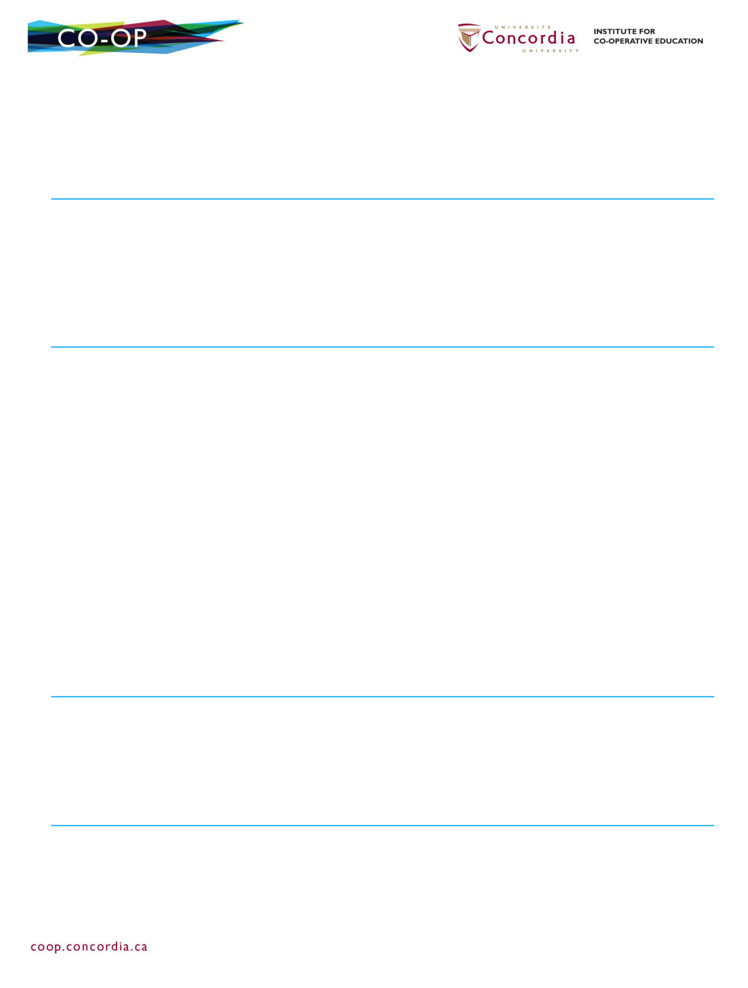**SHADI JIHA**

[shadijiha@gmail.com](mailto:shadijiha@gmail.com)

299 rue Charron. Contrecœur, Québec J0L 1C0

(514) 570-2400

**EDUCATION**

|  |  |
| --- | --- |
| **Bachelor of Computer Science – General program Co-op** | **2019–2022** |
| Concordia University, Montreal, QC |  |
| **DEC in Pure and Applied Sciences** | **2019** |
| Cégep de Sorel-Tracy, Sorel-Tracy, QC |  |

**WORK EXPERIENCE**

**Website Manager**

Bijouterie Hamel, Contrecœur, QC

**May 2018–September 2019**

* Managing store’s social media and interacting with costumers **Core Competencies:** Oral and written communication

**Touristic Guide**

**June 2019–September 2019**

Maison Lenoblet-du-plessis Museum, Contrecœur, QC

* Take care of old material that needs to be handled carefully **Core Competencies:** Memorizing, Teamwork

**Day Camp Leader**

Camp de jour, Contrecœur, QC

**June 2017–August 2017**

* Collaborate in the organization and animation of special days
* Ensures the safety of children

**Core Competencies:** Decision-making, Teamwork, Patience, Vigilance

**PROJECTS**

•

•

**Simple 3D engine from scratch with C++ (Personal)**

**2D GUI sudoku solver (Personal)**

**2019–present**

**2019–present**

* **2D HTML canvas game (Personal)**

**SUMMARY OF SKILLS AND QUALIFICATIONS**

**Applications │** Microsoft Office•Microsoft Visual Studio• Eclipse •GitHub

**Programming │** C/C++ • C# • Python (beginner) • Java • JavaScript/TypeScript • HTML • CSS

**Languages │** French │ Spoken & Written • English │ Spoken & Written • Arabic │ Spoken & Written

**Licenses & Certifications│** Valid driving permit